A Project Proposal Report on
PUBG Team Performance Analyzer: An OOP-Based Esports Analytics Tool in C++
Submitted in Partial Fulfilment of the Requirements for
the Course in Object-Oriented Programming with C++
King's College, Kathmandu
Submitted by:
Sahil Khan Miya
BSCS, Second Year
Date:
August 2026

Department of Computer Science
WESTCLIFF UNIVERSITY
In Academic Collaboration with King's College, Kathmandu

ABSTRACT
The “PUBG Team Performance Analyzer” is a console-based C++ application designed to help esports analysts and team captains evaluate the performance of a four-player PUBG Mobile squad using objective, role-based statistics rather than subjective impressions of how a match went. After each scrim or tournament match, the analyst records each player's raw performance data, including kills, damage dealt, survival time, and assists. The system then calculates an individual performance rating for each player using a role-specific formula, since a Fragger, Assaulter, Support, and In-Game Leader (IGL) are not expected to contribute in the same way. The application aggregates these individual ratings into a team-level report that identifies the most valuable player, the weakest link, and the overall consistency of the squad across matches. The project is built entirely around core object-oriented programming principles, including encapsulation, constructor overloading, hierarchical and multilevel inheritance, pure virtual functions, run-time polymorphism, operator overloading, and static class members. The system is intended as a lightweight, practical alternative to manual spreadsheet-based scrim reviews and reflects a real workflow used by competitive esports organizations.

Keywords: Object-Oriented Programming, C++, Esports Analytics, Polymorphism, Inheritance, Performance Rating

TABLE OF CONTENTS
1. INTRODUCTION 1
1.1 PROBLEM STATEMENT 1
1.2 OBJECTIVES 1
1.3 SCOPE AND LIMITATIONS 2
2. LITERATURE REVIEW 3
3. SYSTEM ANALYSIS AND DESIGN 4
3.1 CLASS HIERARCHY 4
3.2 SYSTEM WORKFLOW 5
3.3 UML CLASS DIAGRAM 6
3.4 USE CASE DIAGRAM 7
3.5 SEQUENCE DIAGRAM 8
4. METHODOLOGY 10
4.1 DEVELOPMENT APPROACH 10
4.2 TOOLS AND TECHNOLOGIES 10
4.3 OBJECT-ORIENTED CONCEPTS APPLIED 10
5. PROPOSED DELIVERABLES 11
6. REFERENCES 12

LIST OF FIGURES
Figure 1: Class Hierarchy of the PUBG Team Performance Analyzer 4
Figure 2: Analyst Workflow from Data Entry to Team Report 5
Figure 3: UML Class Diagram of the PUBG Team Performance Analyzer 6
Figure 4: Use Case Diagram of the PUBG Team Performance Analyzer 7
Figure 5: Sequence Diagram: Recording Match Statistics and Generating a Team Report 8

LIST OF TABLES
Table 1: Role-Based Weighting Used in performanceRating() 9
Table 2: OOP Concepts Demonstrated in the System 10

1. INTRODUCTION
Competitive PUBG Mobile has grown into a structured esport in which teams such as Cute Crushers regularly play scrims and tournaments to prepare for official matches. After each match, coaches and analysts need to understand how well each player performed, not just whether the team won or lost. In most amateur and semi-professional settings, this review process is done manually using spreadsheets or by relying on the team's general impression of the match, which is inconsistent and difficult to track over time. This project proposes a C++ console application that formalizes this review process by allowing an analyst to input raw match data for each of the four players on a squad and automatically generate role-aware performance ratings and a team-level report.
1.1 PROBLEM STATEMENT
Raw PUBG match statistics such as kills, damage, and survival time do not mean the same thing for every player, because each player is typically assigned a distinct in-game role. An Assaulter who engages aggressively at close-to-mid range and deals high damage but survives only a short time is not necessarily performing worse than a Support player who survives the full match but records very few kills. Judging every player against the same standard produces misleading conclusions about who is carrying the team and who needs to improve. There is currently no lightweight tool that lets a student-level analyst enter basic match data and receive a fair, role-adjusted evaluation of each player without relying on manual spreadsheet formulas.
1.2 OBJECTIVES
i. To design a role-based player performance rating system that scores Fraggers, Assaulters, Support players, and IGLs according to different, appropriate criteria.
ii. To implement a C++ class hierarchy that demonstrates encapsulation, hierarchical and multilevel inheritance, and run-time polymorphism through a realistic, non-trivial use case.
iii. To allow an analyst to record match statistics for a four-player team and generate an automated team performance summary.
iv. To identify, from the entered data, the most valuable player, the weakest performer, and the consistency of each player across multiple matches.

1.3 SCOPE AND LIMITATIONS
The scope of this project covers a single squad of four players and supports entry of match statistics for an arbitrary number of matches per player, since each player stores a history of match records. The system supports four roles: Fragger, Assaulter, Support, and IGL, each with its own rating formula. The application is a console-based program and does not include a graphical interface, persistent file storage, or network features in its first version; these are identified as future scope. The rating formulas used are reasonable approximations based on publicly understood esports scoring logic and are not derived from official PUBG Mobile Esports scoring documentation, since that data is not publicly available in a form suitable for a student project.

2. LITERATURE REVIEW
Performance analysis is a well-established discipline in traditional sport science, but its application to esports is comparatively recent (Novak et al., 2020). Novak et al. (2020) modelled team and player performance at a major League of Legends tournament and argued that esports metrics must be interpreted relative to a player's assigned role rather than compared uniformly across all players, since different roles are expected to contribute in fundamentally different ways to a team's success. This directly supports the role-based rating approach adopted in the present project.
Similarly, Nagorsky and Wiemeyer (2020) proposed an integrative performance model for esports that combines concepts from sport science and game research, and found through a large-scale survey that competence requirements differ substantially across games and player roles. Their findings reinforce the position that a single, undifferentiated scoring formula is inadequate for evaluating esports players fairly.
Work on quantitative rating systems has also emerged in adjacent titles. Pradhan and Abdourazakou (2020) applied a multi-criteria decision-making approach to rank professional esports teams using several weighted performance criteria simultaneously, demonstrating that a single raw statistic, such as kills, is an insufficient basis for evaluation on its own. Likewise, Xenopoulos et al. (2020) developed an action-valuation model for Counter-Strike: Global Offensive that assigns different weights to in-game actions depending on their contribution to winning, rather than counting all actions equally. These works support the design decision, in the present project, to weight each role's rating formula according to the statistics most relevant to that role's responsibilities.
At the introductory level, Rubleske et al. (2020) note that esports analytics is an accessible and motivating context for teaching data-oriented programming concepts to students, since the underlying data (kills, damage, survival time) is intuitive and the student is often already familiar with the game being analyzed. This observation directly motivated the choice of an esports analytics tool as the subject of the present object-oriented programming project.
From a software design perspective, this body of research also represents a reasonable case study for demonstrating object-oriented design, since a role-based rating system maps naturally onto an inheritance hierarchy: a general Player concept is specialized into more specific role types, each of which overrides a shared rating behavior. This mirrors patterns commonly taught in introductory OOP courses, such as employee-payroll or shape-area examples, but applies them to a domain that is directly relevant to the student's own extracurricular activity in esports.
3. SYSTEM ANALYSIS AND DESIGN
3.1 CLASS HIERARCHY
The system is centered on an abstract base class, Player, from which two intermediate classes, CombatRole and UtilityRole, are derived, representing multilevel inheritance. Four concrete role classes, Fragger and Assaulter under CombatRole, and Support and IGL under UtilityRole, complete a four-level hierarchy. The Player class declares a pure virtual function, performanceRating(), which forces every concrete role class to supply its own rating logic and prevents a plain Player object from ever being instantiated directly. A separate MatchStats class stores the raw statistics for a single match, and each Player holds a collection of MatchStats objects to preserve a full match history rather than a single snapshot. A Team class aggregates exactly four Player objects and exposes analyst-facing functions such as identifying the most valuable player and the weakest performer.
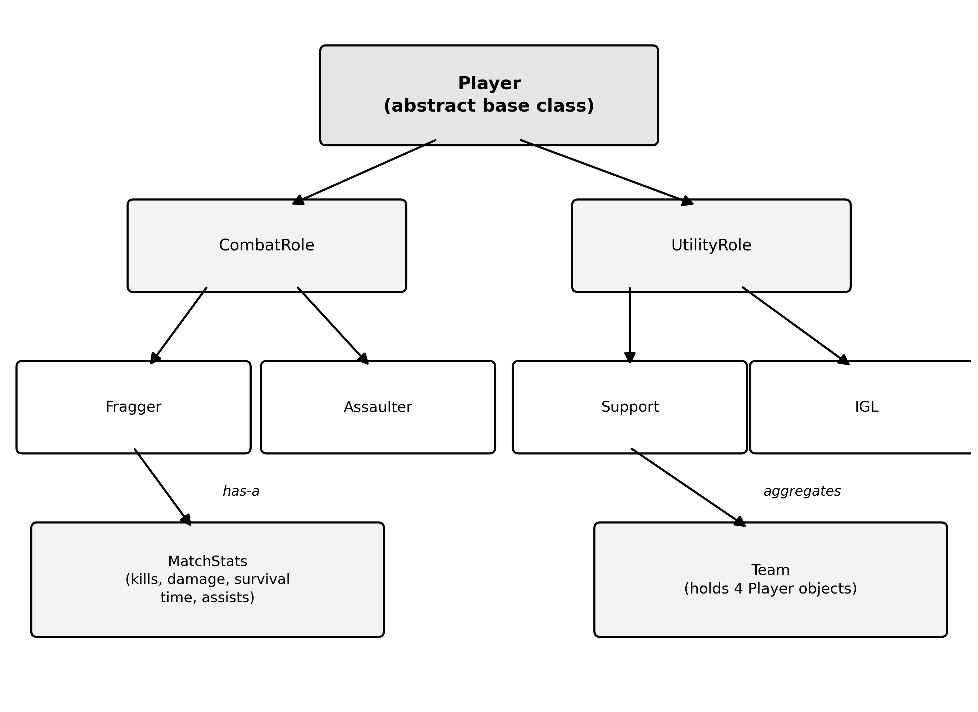
Figure 1: Class Hierarchy of the PUBG Team Performance Analyzer

3.2 SYSTEM WORKFLOW
The application follows a linear, analyst-driven workflow. The analyst first creates a Team object, then adds four Player objects to it, assigning each one a role. For every scrim or match, the analyst enters that player's raw statistics, which are stored as a new MatchStats record. The system then computes each player's performanceRating() using the formula defined by their specific role class, and the Team object compiles these individual ratings into a single team report.
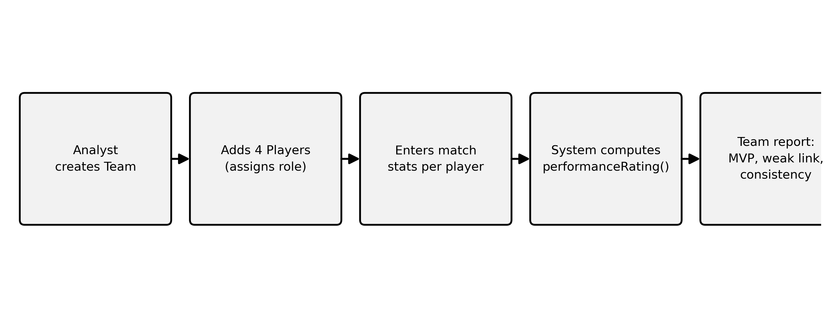
Figure 2: Analyst Workflow from Data Entry to Team Report

3.3 UML CLASS DIAGRAM
Figure 3 presents the formal UML class diagram for the system, showing each class's attributes, methods, and visibility, together with the inheritance and aggregation relationships already outlined conceptually in Figure 1. The Player class is marked as abstract because its performanceRating() method is declared pure virtual, and the diagram shows the multilevel inheritance path from Player through CombatRole and UtilityRole down to the four concrete role classes. The aggregation relationships show that each Player maintains one or more MatchStats records and that each Team aggregates exactly four Player objects.
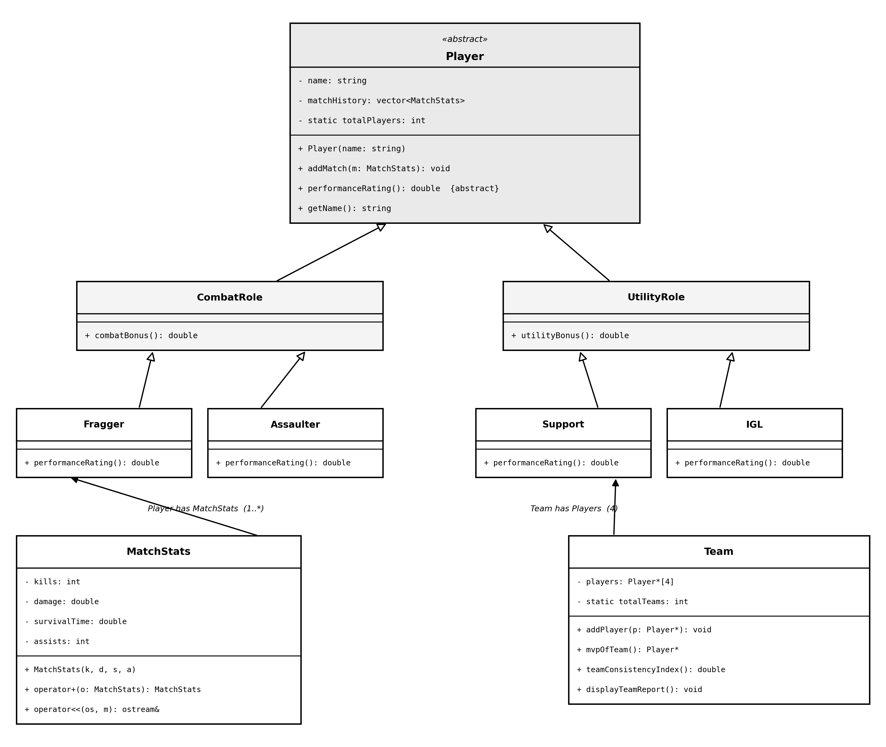
Figure 3: UML Class Diagram of the PUBG Team Performance Analyzer

3.4 USE CASE DIAGRAM
Figure 4 shows the use case diagram for the system. The Analyst is the sole actor, since the application is a single-user console tool operated directly by the person reviewing team performance. The primary use cases are creating a team, adding players with an assigned role, and entering match statistics. Two include relationships are shown: entering match statistics includes computing the performance rating, since a rating is always recalculated whenever new data is entered, and viewing the team report includes identifying the most valuable player and the weakest performer, since these two outputs are always generated together as part of the same report.

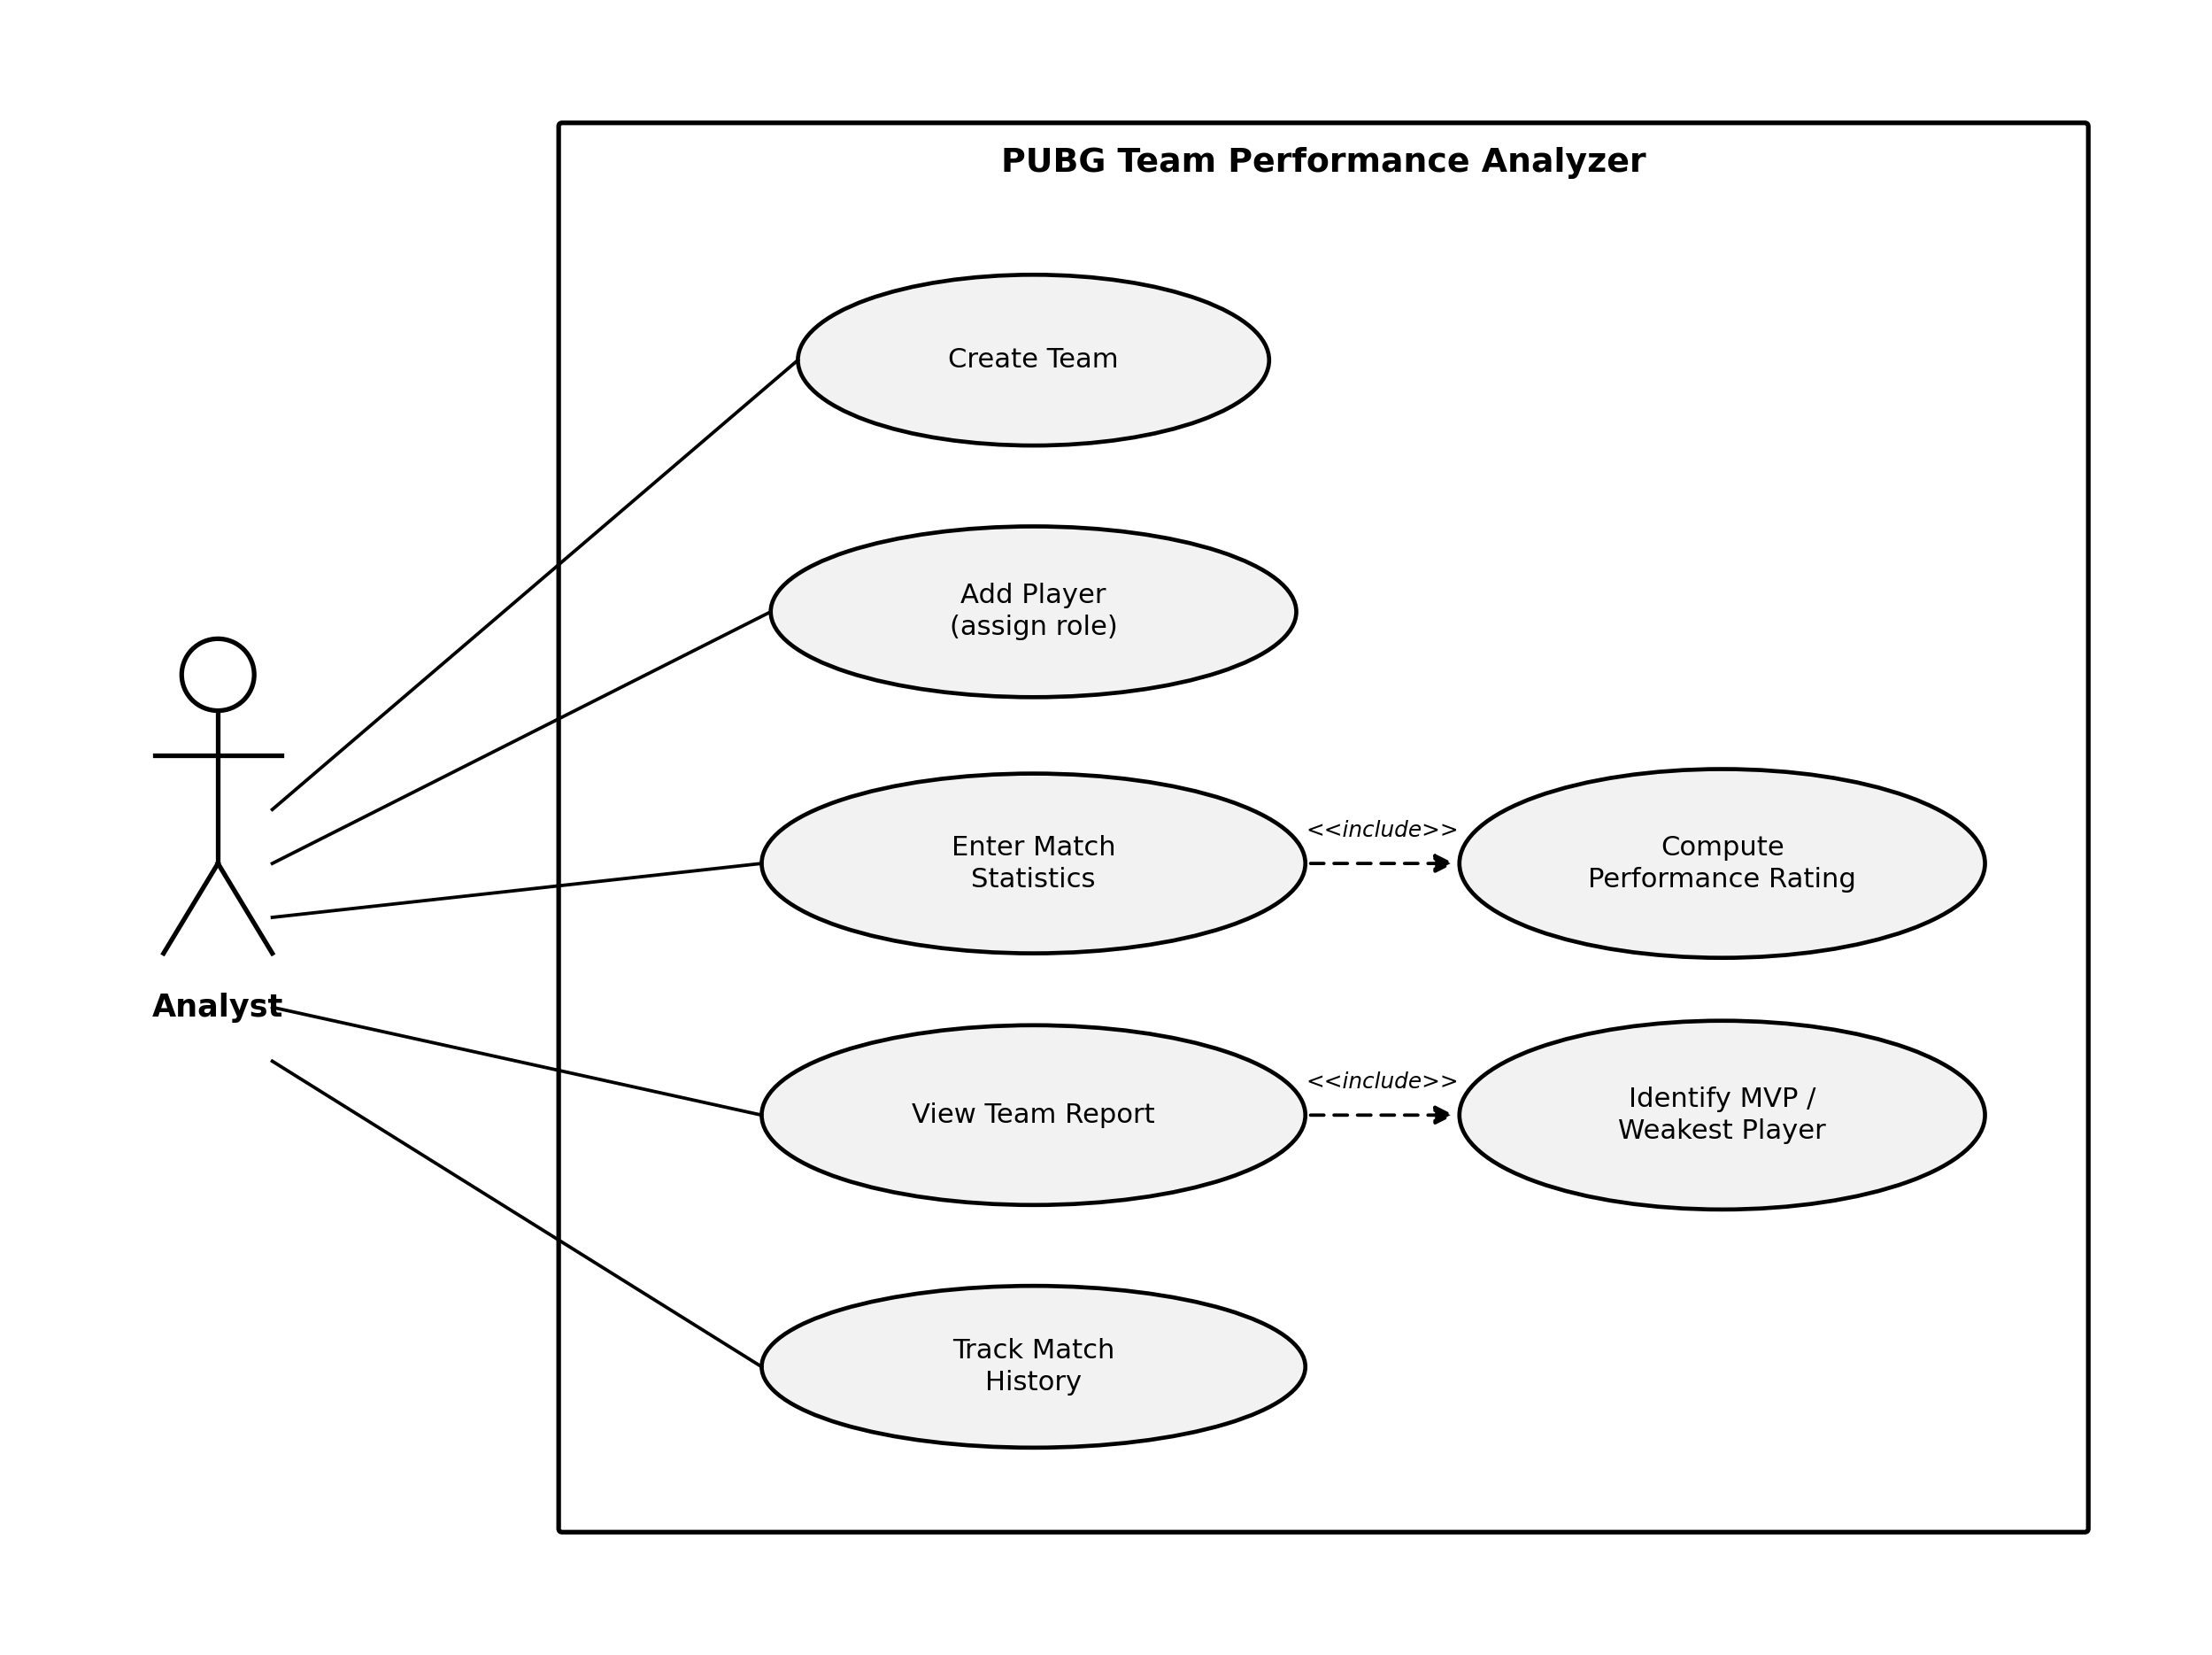
Figure 4: Use Case Diagram of the PUBG Team Performance Analyzer

3.5 SEQUENCE DIAGRAM
Figure 5 illustrates the sequence of interactions that occur when the analyst enters match statistics for a player and later requests a team report. The Analyst first adds a player and enters that player's match statistics through the Team object, which forwards the raw data to the corresponding Player object. The Player constructs a new MatchStats object and stores it in its match history. When the analyst later requests the team report, the Team object queries each Player for its performanceRating(), which in turn retrieves the relevant statistics from MatchStats before returning a computed value. The Team object then aggregates all four ratings to determine the most valuable player, the weakest performer, and the team's overall consistency before returning the completed report to the analyst.
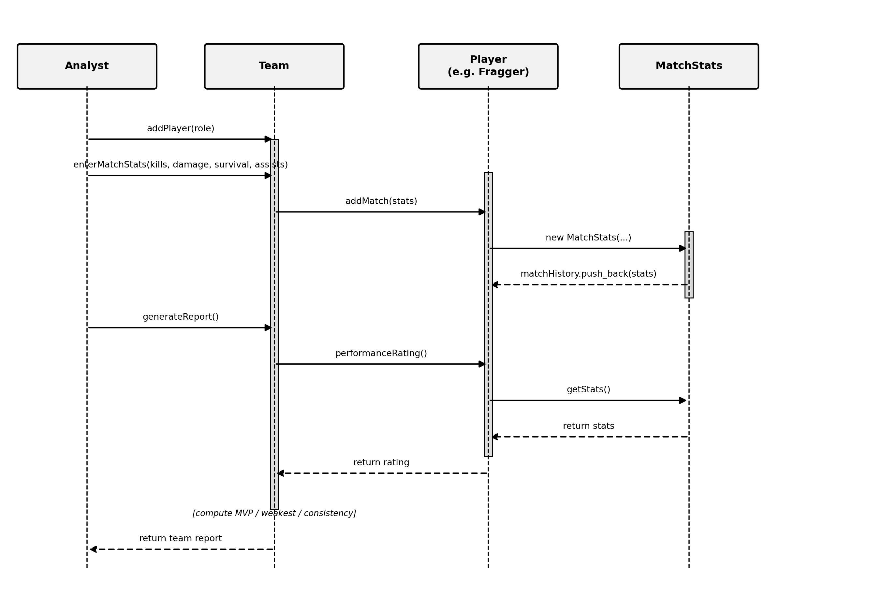
Figure 5: Sequence Diagram: Recording Match Statistics and Generating a Team Report

Role | Primary Weighting Factors | Rationale
Fragger | Kills, damage dealt | Expected to secure eliminations and deal high damage
Assaulter | Damage, kill participation | Expected to engage aggressively at close-to-mid range and contribute consistently to fights
Support | Assists, survival time | Contributes by enabling teammates and staying alive to sustain fights
IGL | Survival time, team placement | Plays a controlling, lower-risk role focused on positioning and calls
Table 1: Role-Based Weighting Used in performanceRating()

4. METHODOLOGY
4.1 DEVELOPMENT APPROACH
The project will be developed incrementally. The first stage will implement the core class hierarchy (Player, CombatRole, UtilityRole, and the four role classes) along with encapsulated data members and constructors. The second stage will implement the MatchStats and Team classes along with the analyst-facing reporting functions. The final stage will focus on testing each role's rating formula against sample match data and refining the console interface for usability.
4.2 TOOLS AND TECHNOLOGIES
i. Language: C++ (standard library only, no external dependencies)
ii. Editor: Visual Studio Code
iii. Compiler: g++ (MinGW), compiled via PowerShell
iv. Version Control: Git and GitHub for tracking incremental development
4.3 OBJECT-ORIENTED CONCEPTS APPLIED
Concept | Application in the System
Encapsulation | Match statistics are private data members accessed only through validated getter and setter functions
Constructor Overloading | A Player can be constructed with a name only, or with a name and an initial MatchStats record
Hierarchical and Multilevel Inheritance | Player derives CombatRole and UtilityRole, which in turn derive the four role classes
Abstraction / Pure Virtual Functions | Player::performanceRating() is declared pure virtual, making Player an abstract class
Polymorphism | Team iterates over Player pointers and calls performanceRating() with each role's own logic executing at run time
Operator Overloading | The + operator combines two MatchStats objects, and << is overloaded for clean report printing
Static Members | A static counter tracks the total number of matches analyzed across all players
Table 2: OOP Concepts Demonstrated in the System

5. PROPOSED DELIVERABLES
The completed project will deliver a working C++ console application that allows an analyst to register a four-player team, record match statistics across multiple scrims, and generate a team performance report identifying the most valuable player, the weakest performer, and each player's consistency across matches. The project will also deliver the accompanying source code, this proposal document, and a brief user guide explaining how to compile and run the program.

6. REFERENCES
Deitel, P., & Deitel, H. (2016). C++ how to program (10th ed.). Pearson.
Lafore, R. (2001). Object-oriented programming in C++ (4th ed.). Sams Publishing.
Nagorsky, E., & Wiemeyer, J. (2020). The structure of performance and training in esports. PLOS ONE, 15(8), Article e0237584. https://doi.org/10.1371/journal.pone.0237584
Novak, A. R., Bennett, K. J. M., Pluss, M. A., & Fransen, J. (2020). Performance analysis in esports: Modelling performance at the 2018 League of Legends World Championship. International Journal of Sports Science & Coaching, 15(5-6), 809–817. https://doi.org/10.1177/1747954120932853
Pradhan, S., & Abdourazakou, Y. (2020). “Power ranking” professional circuit esports teams using multi-criteria decision-making (MCDM). Journal of Sports Analytics, 6(1), 61–73. https://doi.org/10.3233/JSA-200402
Pressman, R. S. (2010). Software engineering: A practitioner's approach (7th ed.). McGraw-Hill.
Rubleske, J., Fletcher, T., & Westerfeld, B. (2020). E-sports analytics: A primer and resource for student research projects and lesson plans. Journal of Instructional Pedagogies, 23, 1–14.
Stroustrup, B. (2013). The C++ programming language (4th ed.). Addison-Wesley.
Xenopoulos, P., Doraiswamy, H., & Silva, C. (2020). Valuing player actions in Counter-Strike: Global Offensive. In 2020 IEEE International Conference on Big Data (pp. 1283–1292). IEEE. https://doi.org/10.1109/BigData50022.2020.9377895

